Registration

Auto-Moto École PEPE

Driving School PEPE

**Driving License B100 (125ccm) (hold a category B driving license for at least 2 years)**

**Documents required for the request in obtaining a driving license:**

|  |  |
| --- | --- |
|  |  |

**1.** From **‘Demande d’obtention d’un permis de conduire’** needs to be signed by the candidate in the upper right corner in the box with a black pen and without touching the black lines.

**2. Recent Identity Photo** (format 45x35mm head taken from the front having at least 20mm height)

**3. Medical Certificate** (less than 3 months old, **VERY IMPORTANT** doctor's signature + stamp) (specific document for the Luxembourg driving license)

**4. Extract of the criminal record of the last place of residence abroad before that in the Grand-Duchy** (if not resident in Luxembourg for at least 5 years) (dated less than 3 months) (Mandatory sworn translation except English, French, German, Italian, Spanish and Portuguese)

**5. Photocopy of a valid ID** (identity card or passport) + (if already holds a driving license, photocopy required, (Luxemburgish driving license or copy of the registration from the SNCA)) (**not member of the EU**: Photocopy residence card)

**6. Photocopy of driving license** (Luxemburgish driving license or copy of the registration from the SNCA with copy of your foreign driving license)

**7. Extract of the Luxembourg Criminal Record Bulletin N°4**   
🡪 Signature of authorization on the document ‘**demande d’obtention/extension d’un permis de conduire’**for the SNCA!

**Registration Fee**

**Tax**

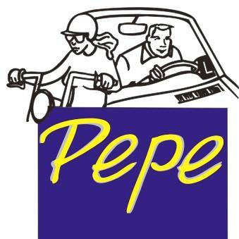**80€ =**

**CASH**

**Minimum of practical lessons:** 7 hours (1h/90€)

**Total practical lessons:** 630€ (pay in advance)

Auto-Moto École PEPE

**Tél. : 46 16 36**

**\*PRICE 2025**